Preconditions

1. Check Out external DataDriver file for specific project.

* Current location: C:\Users\287926\OneDrive - Maximus, Inc\Documents\Project\VA EB\Data\ DataDriver_VAEB_Export.xsls

1. Open file.
2. Append new records (based on current ticket) or use existing records, if applicable.

Verify inserted data is correct.

1. Update: First column (Flag) for records, you would like to include in automation run with value: Y
2. Update all other columns based on ticket requirements

Use **DataDriver_Tamplate.xls** and **Options-Selections examples.doc** as examples.

NOTE: Each report consists on 3 records:

* Export – Excel report.
* GUI – Grid report.
* SQL – Report generated by executing SQL statement.

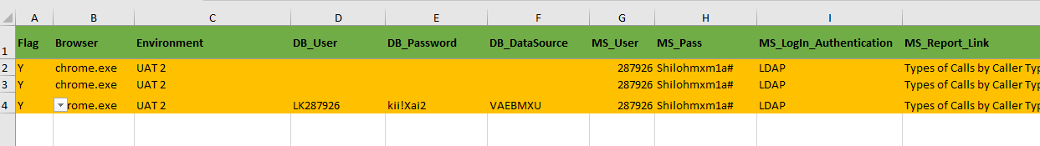

1. Open UFT – Appropriate script (Example: Script: PA IEB. Action: Export)
2. Run Script.
3. Script details:
   1. Get path of local DataDriver.xlsx
   2. Read file and collect all rows with value “Y”

Start LOOP

* 1. Get first index of line with value “Y”
  2. Clear local Download folder.
  3. Read appropriate line in DataDriver.xlsx file and bring all variables into the script.
  4. Open appropriate browser/URL
  5. Log on into application
  6. Select (navigate) through appropriate folders according requirements.
  7. Select Export link for correct report.
  8. Go to correct **CASE** block based on selection option.

Example:

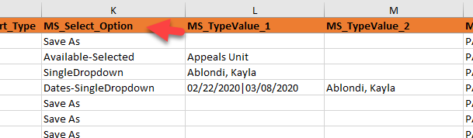

* 1. Enter option values (if applicable).

Note. Enter Default value into column MS_TypeValue_1 if you would like to bypass options selection.

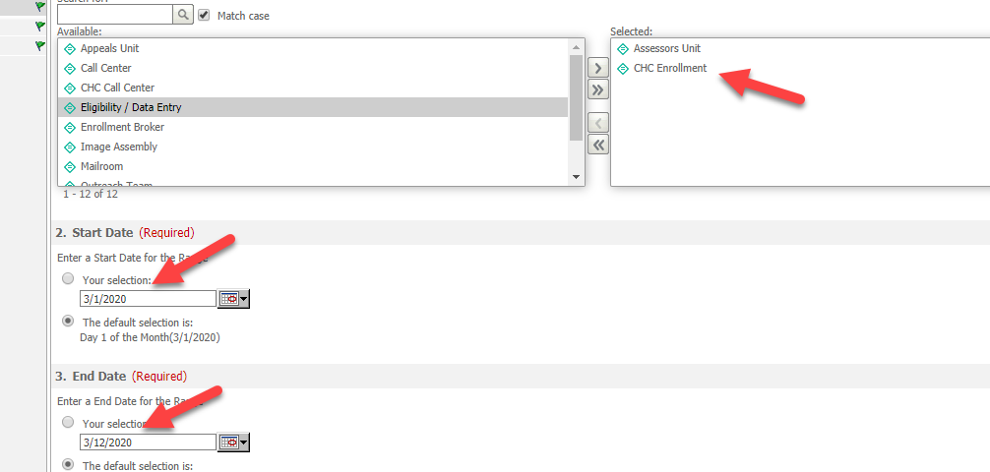

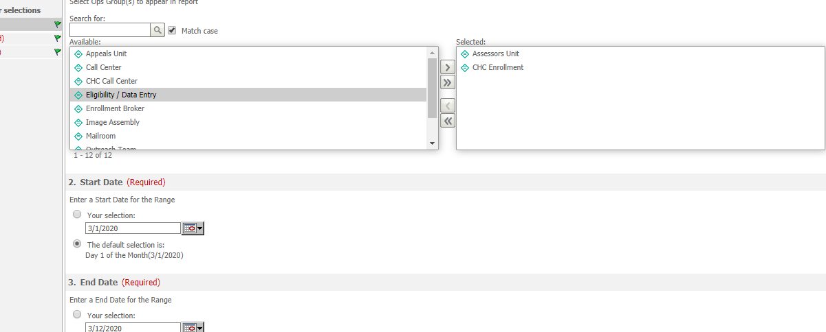

* 1. Export RUN:
* Wait until report is downloaded into local Download folder.
* Copy report to local Report folder.
* Validate report
  1. GUI RUN:
* Wait until report grid appears
* Validate data in grid
  1. SQL RUN
* Execute SQL statement.
* Create and load excel file (file name: Report name + “_SQL”)
* Validate report.
* Save report into local Report folder.

1. End LOOP